- Nmap
  - Host Discovery
Code snippets: Nmap –sn 10.6.6.0/24
- Nmap (Network Mapper) – It is a network scanning tool.
- -sn is Ping Scan
  - -s = Scan type flag
  - n = No port scan (just host discovery)
- 10.6.6.0/24 (Target Specification)
  - 10.6.6.0 = Network address
  - /24 = CIDR notation (subnet mask)
  - This represents the IP range: 10.6.6.0 to 10.6.6.255 , 254 possible hosts (.0 is network, .255 is broadcast)
- It checks if hosts are alive, But it doesn't scan ports
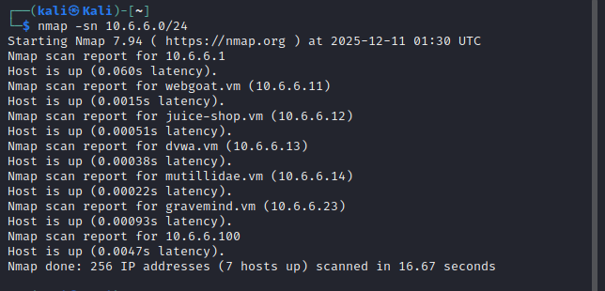
  - Port scanning
Code snippets: sudo nmap –O 10.6.6.23
  - sudo - Super User Do because OS detection requires raw socket access (privileged)
  - -O (OS Detection): Identify the operating system of target host
  - 10.6.6.23: Single target IP address
What This Command Actually Does:
- Discovers if host is alive
- Performs port scan to find open ports (for fingerprinting) as shown in the screenshot
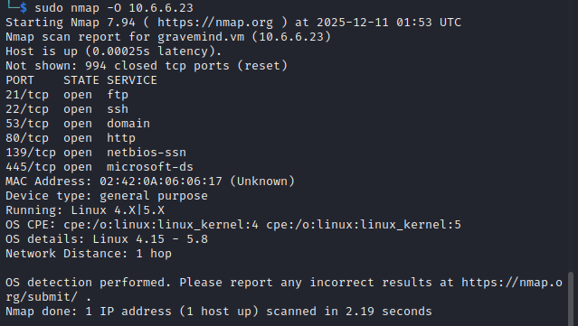
  - Service detection
Code snippets: nmap -p21 -sV -A T4 10.6.6.23
- -p21
- Meaning: Scans only port 21.
- Purpose: Port 21 is the default port for the FTP (File Transfer Protocol) service. Accordingly, the command checks the FTP service on this target.
- -sV
- Meaning: Enables Version Detection.
- Purpose: Nmap will not just see if the port is open; it will probe the service to determine what specific application and version is running. This helps to identify known vulnerabilities.

- -A
- Meaning: Enables Aggressive Scan mode. This is a powerful combination flag that activates:
  - OS Detection (-O): Attempts to identify the target's operating system.
  - Version Detection (-sV): Already specified separately, so it's reinforced.
  - Script Scanning (-sC): Runs a default set of Nmap Scripting Engine (NSE) scripts against the target. These scripts can discover vulnerabilities, extract further service info, or perform safe exploitation.
  - Traceroute: Traces the network path to the host.
- T4
  - -T4 (Aggressive) assumes a fast, reliable network. It sets the timing template to "Aggressive," making the scan faster.

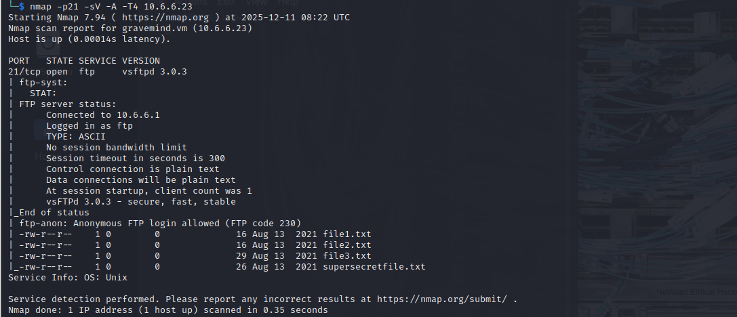

Code snippets: nmap -A -p139, 445 10.6.6.23
- Aggressive scan on port 139 and 445. Port 139 is NetBIOS Session Service and Port 445 is SMB over TCP
  - Basic scripting
Code snippets: nmap --script smb-enum-shares.nse -p445 10.6.6.23
- --script smb-enum-shares.nse: Loads the SMB share enumeration script
- -p445: Only scans port 445 (SMB direct over TCP)
- 10.6.6.23: Target IP address
What it does
- Attempts to establish an SMB connection to 10.6.6.23 on port 445
- Default behavior: Uses NULL authentication (no credentials)
  - Tries to connect with blank username/password
  - Attempts to list shares without proper credentials
- Information Collected
If successful, the script returns:
  - Share names (e.g., C$, ADMIN$, IPC$, Public)
  - Share types (disk, printer, IPC, hidden)
  - Comments/descriptions (often revealing share purpose)
  - Permissions (read/write access if accessible)
  - Current user access (what the NULL session can do)
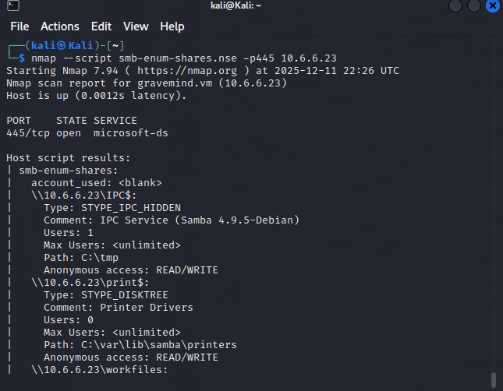

Critical Finding: The enumeration succeeded with NULL/blank credentials.
- Anonymous/guest access is enabled
- No password required for share enumeration
- Complete failure of basic authentication controls

B) Scapy
1. Packet crafting
2. Packet Sending
3. Packet Sniffing
4. Basic Protocol Analysis

